Lady Denman Cup Competition 2020
‘What I heard on the bus…’

Schedule
Using no more than 500 words, WI members are invited to submit a piece of writing, either comical, serious, fact or fiction, based on a conversation they have overheard, or imagined they had heard, on the bus.

Entrants must submit four copies of their entry, typed if possible, on A4 paper to the Federation Secretary (Rachel Hows) no later than Friday 18 September 2020. Entries can be submitted either via email or by hard copy. Please do not send entries directly to NFWI. Any entries sent directly to the NFWI Unit without being approved by the federation, cannot be entered and will be returned to the entrant.

Entries must be accompanied by a completed Individual Entry Form (see attached).

Please note:
- Each entry must include a total word count on each copy; entries with over 500 words will not be accepted.

- All entries will be judged in the first instance at federation level and up to three entries from each federation can go forward to the national competition. Successful entries will be submitted to NFWI no later than Friday 16th October. 2020. Results will be announced by mid-December 2020.

- All entries at national level will receive a critique by the Judge.

- Late entries will not be accepted.

- All forms relating to the competition can be downloaded from My WI or from your Federation Secretary.

Prizes
Book tokens will be given as prizes: 1st prize, book tokens to the value of £75; 2nd prize book tokens to the value of £50 and 3rd prize book tokens to the value of £30. The winner/winning federation will be presented with the Lady Denman Cup.

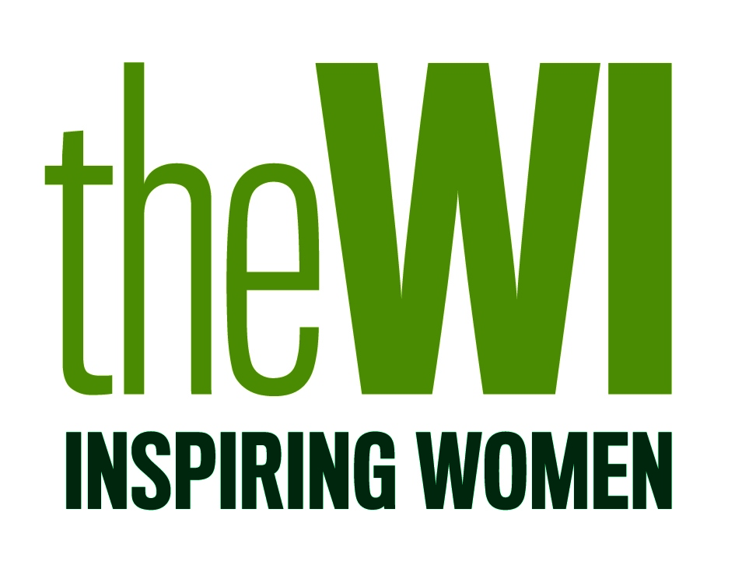
LADY DENMAN CUP COMPETITION 2020
‘What I heard on the bus…’

Individual Entry Form
Postal Entries: Please attach this form to the top copy of your entry. You must submit four copies; your name, WI and federation must be clearly written in the top left hand corner of the first copy ONLY. The remaining copies must be kept anonymous.
Return to: Rachel Hows, Federation Secretary, Unit 11, Park Farm Business Centre, Fornham St Genevieve, Suffolk, IP28 6TS.
Email Entries: Please email a completed copy of this form with your entry to office.swfwi@gmail.com
- Please ensure your name, WI and federation are only written on the first copy; entrants details must not be written on the remaining copies.

- Each entry must include a total word count; entries with over 500 words will not be accepted.

- Your entry must be submitted to the Federation Secretary by Friday 18 September 2020 for initial judging.

- The competition is open to all WI members and Associates. One entry per member.

Surname (Ms/Mrs/Miss) …………………………………………………………………………………………………………………….

First Name ………………………………………………………………………………………………………………………………………….

Address ………………………………………………………………………………………………………………………………………………
……………………………………………………………………………………………………………………………………………………………
……………………………………………………………………………………………. Post code ……………………………………………
Telephone…………………………………………………………………………………………………………………………………………..
Email ………………………………………………………………………………………………………………………………………………….
WI ………………………………………………………………………………………………………………………………………………………
Federation …………………………………………………………………………………………………………………………………………
I agree that if my entry is one of the three national winners, the NFWI shall have the right to publish it in WI Life and on the NFWI and My WI websites.
SIGNED:................................................................................. DATE: .............................................................

